Getting Started with PAX Fabric - Enterprise AI Analytics Pipeline

Document version: 1.1
Updated: October 13, 2026
PAX parity: v1.11.16-prerelease-20260916-06

PAX Fabric is an enterprise analytics workload for Microsoft Fabric that helps organizations collect, process, and prepare tenant-wide AI activity, Microsoft 365 usage, user, and agent data for reporting and analysis.
The workload provides a managed experience for deploying the required Fabric resources, configuring data collection, running the pipeline on demand or on a schedule, monitoring execution, and connecting the resulting Lakehouse data to ready-to-use reporting templates.
PAX Fabric runs natively in Microsoft Fabric. Collected and processed data is stored as Delta tables in OneLake, allowing organizations to maintain their analytics workflow within their Fabric environment.

Contents
What You Can Do with PAX Fabric 2
How PAX Fabric Works 2
End-to-End Workload Flow 2
Solution Resources and Services Flow 2
Resources Created by the Workload 3
Before You Begin 3
Get Started 4
1. Create a PAX Fabric Pipeline Item 4
2. Deploy the Fabric Resources 5
3. Configure the Workload 5
Understanding PAX Configuration 6
Run the Pipeline 6
Create Recurring Schedules 7
Monitor Runs 8
Update Resource Definitions 8
Review the Lakehouse Output 9
Connect the PAX Report Templates 9
Support, Licensing and Data Handling 10
Related Fabric Resources 10

What You Can Do with PAX Fabric
PAX Fabric enables you to:
- Consolidate supported AI activity and Microsoft 365 usage data in a single Lakehouse.
- Collect a selected historical date range or maintain a rolling dataset through recurring schedules.
- Enrich activity data with user, license, organizational, and agent context.
- Apply user or group filters to control the collection scope.
- De-identify user information where required.
- Produce raw, rolled-up, or combined output for different reporting requirements.
- Use incremental processing and checkpoint-based continuation for recurring data collection.
- Monitor on-demand and scheduled runs directly from the workload.
- Connect the generated Lakehouse tables to the supplied Power BI report templates.

How PAX Fabric Works
The PAX Fabric Pipeline item is the central management experience for the workload. From this item, you can deploy resources, maintain configuration, start runs, create schedules, monitor execution, and open the related Fabric items.
The workload separates shared configuration from execution-specific parameters. Shared settings are maintained through the PAX Fabric Pipeline item and its Variable Library, while on-demand runs and schedules can supply their own collection parameters to the shared Data Pipeline.

End-to-End Workload Flow
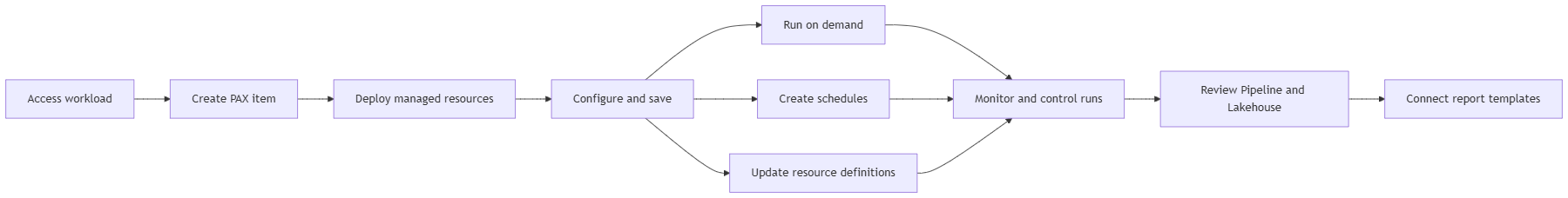

Solution Resources and Services Flow
The PAX Fabric Pipeline item is the user entry point and control plane. It connects Microsoft Entra identity, Azure Key Vault, the public PAX-Fabric GitHub repository, Microsoft 365 data sources, and the Fabric resources that perform collection, transformation, storage, and reporting:
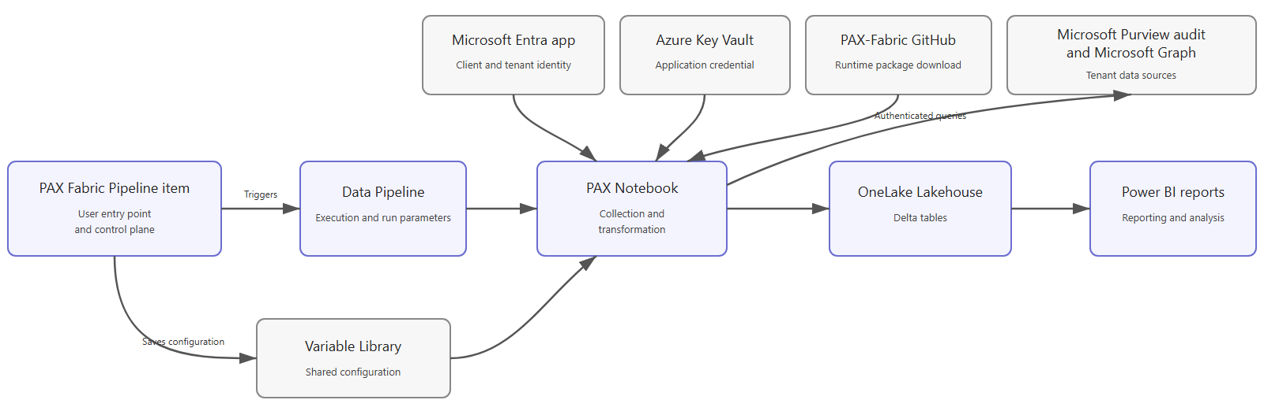

Resources Created by the Workload
When you deploy resources from a PAX Fabric Pipeline item, the workload creates and connects the following Fabric items in the selected workspace:
Resource | Purpose
Variable Library | Stores shared configuration, including identity references, Key Vault references, target schema, retention, concurrency, partitioning, and source settings.
Lakehouse | Stores processed AI activity, Microsoft 365 usage, user, agent, and dimensional data as Delta tables in OneLake.
Notebook | Contains the PAX collection and transformation logic and writes the processed output to the Lakehouse.
Data Pipeline | Orchestrates Notebook execution and supplies parameters for on-demand and scheduled runs.
These resources are created as separate Fabric items and can be opened from the workspace.

Before You Begin
Confirm that the following requirements are available:
- PAX Fabric is enabled and visible in your Fabric tenant.
- You have access to a capacity-backed Fabric workspace.
- You can create and manage Fabric items in the selected workspace.
- An approved Microsoft Entra application is available for the required data collection.
- The application credential is stored in Azure Key Vault.
- You know the application Client ID, Tenant ID, Key Vault URI, and Key Vault secret name.
- You have selected the Lakehouse schema in which PAX output tables will be created.
- You understand the required collection scope, privacy options, and retention period.
- Microsoft Purview Audit is enabled for the tenant.
- The user who runs an on-demand pipeline and the owner of each schedule have the Key Vault Secrets User role on the vault.
- You have confirmed the tenant's available audit history. Microsoft Purview Audit (Standard) retains audit records for 180 days by default; licensing and retention policies can provide a different window.
- The Fabric capacity can support the requested backfill. Large historical windows can run for hours or days and consume significant capacity.

Grant tenant-wide administrator consent for these Microsoft Graph application permissions:
Permission | Needed for
AuditLogsQuery.Read.All | Microsoft Purview audit collection across the supported audit workloads.
User.Read.All | Entra user collection and user-manager enrichment.
Organization.Read.All | Tenant organization and subscribed-license SKU information.
GroupMember.Read.All | Group filtering and transitive group-member expansion.
CopilotPackages.Read.All | Agent 365 catalog collection.

When AuditLogsQuery.Read.All is granted, AuditLogsQuery-Exchange.Read.All, AuditLogsQuery-OneDrive.Read.All, and AuditLogsQuery-SharePoint.Read.All are not required.

Enter the Key Vault secret name, not the credential value. The credential value must remain in Azure Key Vault.

Get Started

1. Create a PAX Fabric Pipeline Item
Open the PAX Fabric workload landing page and select PAX Fabric Pipeline under Item types. Enter an item name, select the target workspace, and create the item.
The new item opens with an environment setup page that lists the Fabric resources required by the workload.

2. Deploy the Fabric Resources
Select Deploy Fabric Resources.
The workload provisions the Variable Library, Lakehouse, Notebook, and Data Pipeline. Deployment progress is displayed for each resource. If deployment is interrupted, selecting the deployment action again attempts to create only the missing resources.

3. Configure the Workload
Complete the shared configuration for PAX Fabric:
Configuration | Description
Client ID | Application ID of the approved Microsoft Entra application.
Tenant ID | Directory ID containing the application registration.
Key Vault URI | URI of the Azure Key Vault that stores the application credential.
Key Vault Secret Name | Name of the Key Vault secret containing the credential.
Target Schema | Lakehouse schema in which PAX creates its output tables.
Keep Scratch | Controls whether intermediate files are retained after a run.
GitHub repository and reference | Identifies the source and version of the PAX modules used by the Notebook.
Max Concurrency | Controls the maximum number of partitions processed in parallel.
Partition Hours | Controls the size of each processing window.
Retention Period | Specifies the number of days prior to today for which data is retained. The default is 0, which retains all rows. Any positive value permanently deletes older rows at the end of every run.
Save the configuration before starting a run. Saving synchronizes the applicable shared values to the managed Variable Library.

The current default GitHub Ref is main. The Notebook downloads the latest code from that branch at the beginning of every run. For reproducible production runs, replace main with an approved immutable commit SHA or release tag.

Understanding PAX Configuration
PAX Fabric separates configuration according to how it is used and where it is maintained:
Configuration type | Where it is configured | Where it is stored or applied | Purpose
Shared configuration | PAX Fabric Configuration page | Saved in the PAX Fabric Pipeline item and synchronized to the managed Variable Library | Applies across on-demand and scheduled runs. This includes identity references, Key Vault references, target schema, retention, concurrency, partitioning, and source settings.
On-demand run parameters | Trigger dialog in the Run view | Passed to the shared Data Pipeline for the submitted run | Applies only to the manually triggered run. This includes the date window, dashboard scope, filters, privacy options, incremental processing, BYOD inputs, and advanced parameters.
Schedule parameters | Create pipeline schedule or Edit pipeline schedule dialog | Stored with the individual Fabric schedule and passed to the shared Data Pipeline when the schedule runs | Applies only to that recurring schedule. Each schedule can retain its own cadence, time zone, active period, enabled state, and execution parameters.
This model allows a single PAX Fabric Pipeline item to support multiple collection profiles while using one shared set of deployed resources.

A run replaces existing rows in the date range it collected before adding the newly collected rows. Before running a different collection scope, edit and save a different Target Schema so overlapping scopes do not write to the same schema. Do not run differently scoped schedules concurrently while they resolve to the same Target Schema.

Run the Pipeline
After saving the shared configuration, open the Run view and select Trigger.
The Trigger dialog allows you to review and configure:
- The collection start and end dates. End Date is exclusive; for example, Start Date 2026-06-01 and End Date 2026-07-01 collect June 2026.
- Dashboard scope, including AI in One, M365, and ValueLens data.
- M365 Usage collection.
- Raw, rollup, rollup-plus-raw, and combined output options.
- User and Agent 365 information.
- Group and user filters.
- De-identification.
- Watermark-based incremental processing.
- Existing Purview or user-information input files.
- Checkpoint-based continuation.
- Additional advanced parameters.
Select Trigger to submit the run. The workload displays a confirmation when the Data Pipeline run has been queued.
For an initial run, consider using a limited date range and the minimum required collection scope. After confirming the expected output, expand the date range or enable recurring schedules as needed.

Enable Include Agent 365 Info when preparing AI in One or ValueLens data so the agent pages can display catalog details. When it is disabled, PAX still creates an empty Agent365 table with the expected schema so the dependent PBIT templates can connect.

Create Recurring Schedules
Use Create schedule from the Run view to automate recurring collection.
PAX Fabric supports:
- By-the-minute schedules.
- Hourly schedules.
- Daily schedules.
- Weekly schedules.
- Monthly schedules.
- Interval-based schedules.
Each schedule can retain its own:
- Enabled or disabled state.
- Start and end date.
- Time zone.
- Cadence and execution time.
- Collection and processing parameters.
Existing schedules can be refreshed, enabled, disabled, edited, or deleted from the Schedules section.

Daily is the recommended cadence because PAX collects audit data in whole UTC days. By-the-minute, hourly, interval-based, and overlapping schedules can re-collect the same day and consume capacity without providing fresher partial-day data. For routine incremental collection, use one daily schedule with NumberOfDays=1, or use Watermark after a successful manual bootstrap.

Monitor Runs
The Recent runs section shows both on-demand and scheduled executions.
For each run, you can review:
- Status.
- Start time.
- Duration.
- Invocation type.
Active runs refresh automatically and can be cancelled from the workload.
The Recent runs section provides a summary of run activity; it does not provide the complete error details for a failed pipeline run. To investigate a failure:
1. Select Open pipeline monitor.
2. Open the Data Pipeline run history.
3. Select the corresponding failed run.
4. Review the failed activity and its error details.

Update Resource Definitions
When a newer workload-managed definition is available, Update resource definitions become available in the PAX item.
The update operation can selectively refresh the managed Notebook, Data Pipeline, or Variable Library definition while preserving:
- The Lakehouse and its Delta tables.
- Existing Fabric item IDs.
- Existing schedules.
- Configuration values entered through the PAX item.
Review the update confirmation before proceeding because manual changes made directly to managed resources can be overwritten.

Review the Lakehouse Output
Select Open Lakehouse from the PAX Fabric Pipeline ribbon.
The Lakehouse contains the Delta tables produced by successful runs. Available tables depend on the selected collection scope and processing options. The configured target schema is used to organize the workload output.
You can use the Lakehouse for:
- Data review and exploration.
- SQL-based analysis through the Lakehouse SQL analytics endpoint.
- Power BI reporting.
- Other approved downstream analytics solutions.

Connect the PAX Report Templates
The PAX-Fabric GitHub repository provides Power BI template files for:
- M365 Usage
- AI in One
- ValueLens

Download the template that corresponds to the data collected by your PAX pipeline and open it in Power BI Desktop.
Each template requires:
Parameter | Source
SQL Endpoint | Copy the SQL connection string from the provisioned Lakehouse under Settings > SQL analytics endpoint.
Lakehouse Name | Use the name of the Lakehouse provisioned for the PAX item.
Schema | Use the Target Schema configured in the PAX Fabric Configuration page.
After entering the parameters, select Load and sign in with an organizational account that can access the Lakehouse.
The selected report template must correspond to data included in a successful PAX run.

Support, Licensing and Data Handling
- PAX Fabric is free and open source under the MIT License: https://github.com/microsoft/PAX-Fabric/blob/main/LICENSE
- Report defects and request support through PAX-Fabric GitHub Issues: https://github.com/microsoft/PAX-Fabric/issues
- Collected data and generated Delta tables remain in the customer's Microsoft Fabric tenant.
- The Notebook downloads the PAX Python package at run time from the public repository and GitHub Ref configured in the PAX item. The default ref is currently main.
- Pipeline and Notebook runs consume the customer's Fabric capacity.

Related Fabric Resources
The Variable Library, Lakehouse, Notebook, and Data Pipeline are separate Fabric items. Deleting the PAX Fabric Pipeline item removes only that item; the four provisioned resources are retained. Review them individually and retain or remove them according to your requirements.

